Table Context

1. Create Value Set
2. Create COA Structure
3. Create COA Instances
4. Deploy COA
5. Enter Values in Value Sets
6. .
7. .
8. .
9. Create DFF for Journal Line
10. Create DFF for Supplier
11. KFF

What is Chart of Account?

It simply **means list of accounts**.

Chart of Accounts (CoA) in Oracle Fusion Cloud allows to create multi-dimensional combinations. Each of these dimensions is called as Chart of Accounts Segments.

Example: You have the following 3 segments

1. Company:  
Sample Value – 20 GOOGLE SERVICES  
2. Department:  
Sample Value – 110 Finance  
3. Account:  
Sample Value – 20110 Revenue Account

In this scenario account combination 20-110-40130 means it is an Expense on Airfare is incurred for Department – Finance for Company – Google Services

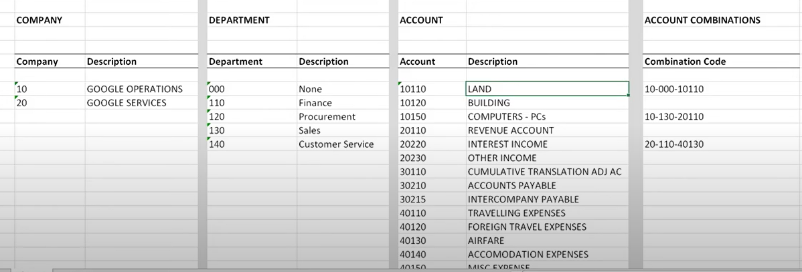

Steps :

1. Create Value Sets
2. Create COA Structure
3. Create COA Instances
4. Deploy COA
5. Enter Values

Now COA is ready to use in Ledger.

1. Create Value Set:  
 Segments – Company, Department and Account  
 Create Value Set for each segment of the Chart of Accounts.

Click on “Manage Chart of Accounts Value Sets”

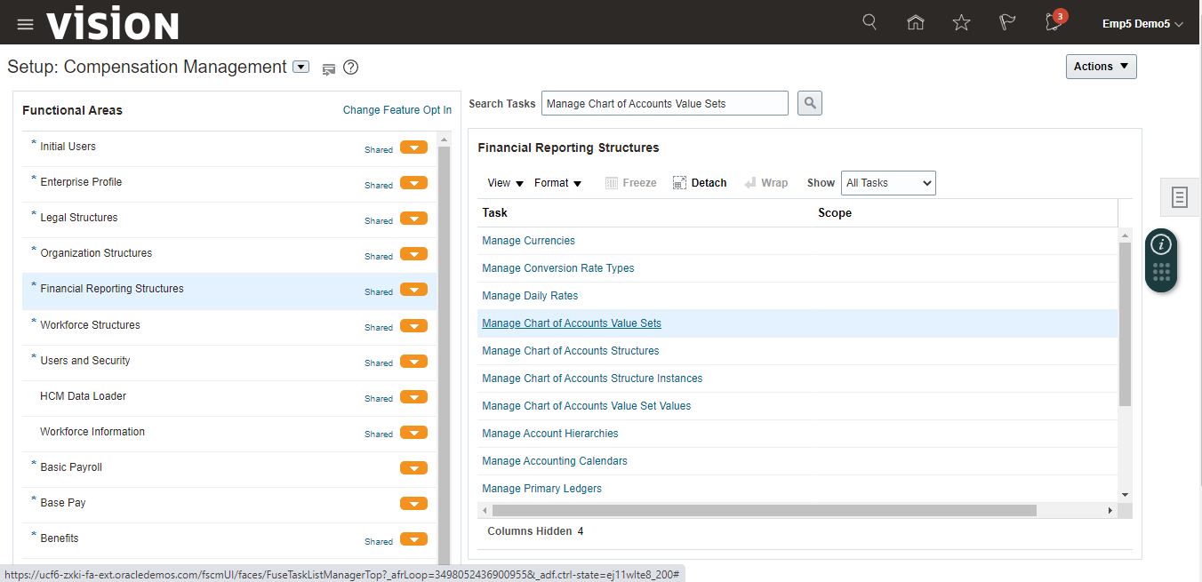  
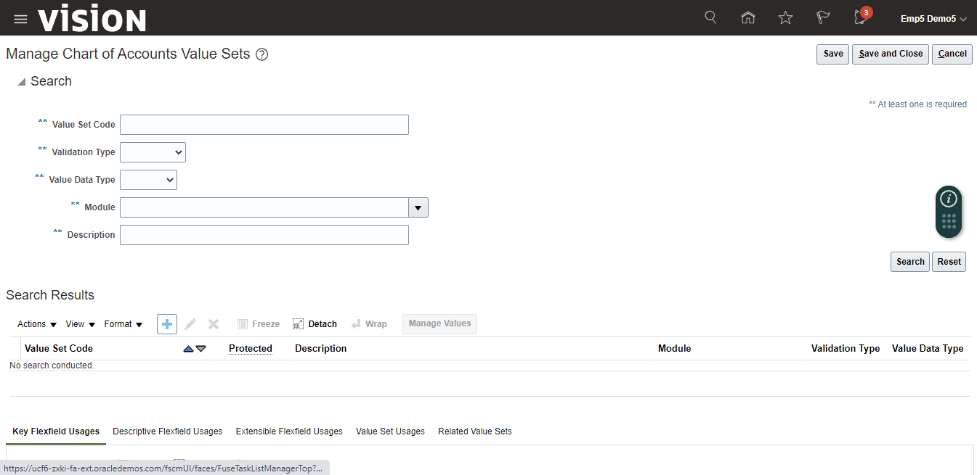

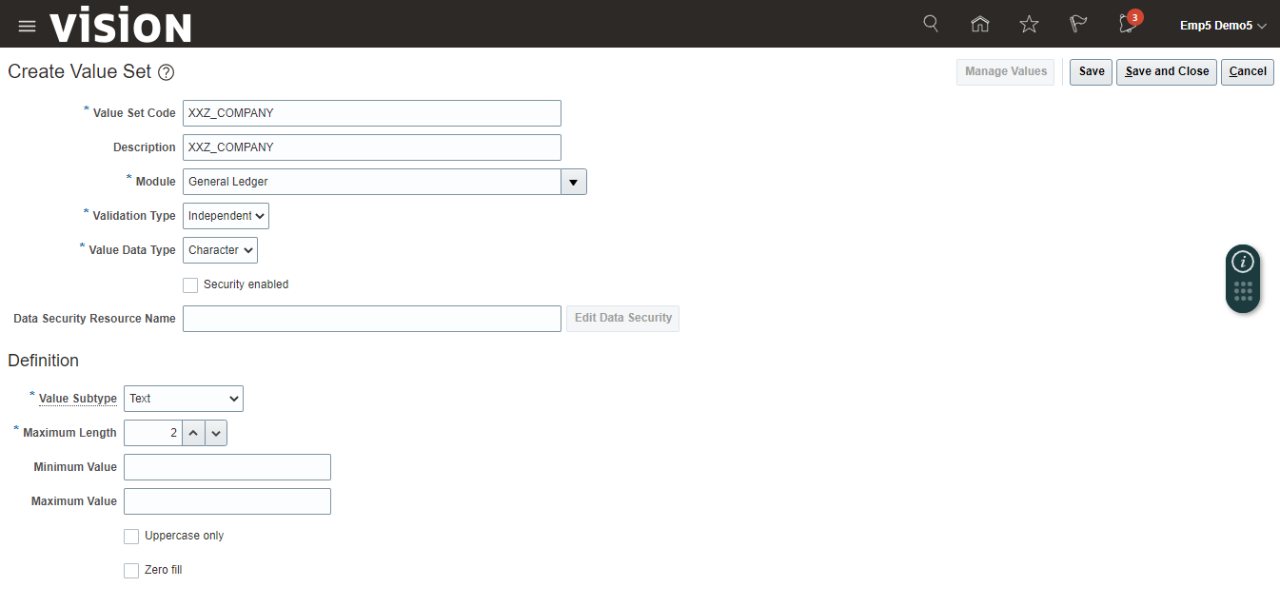

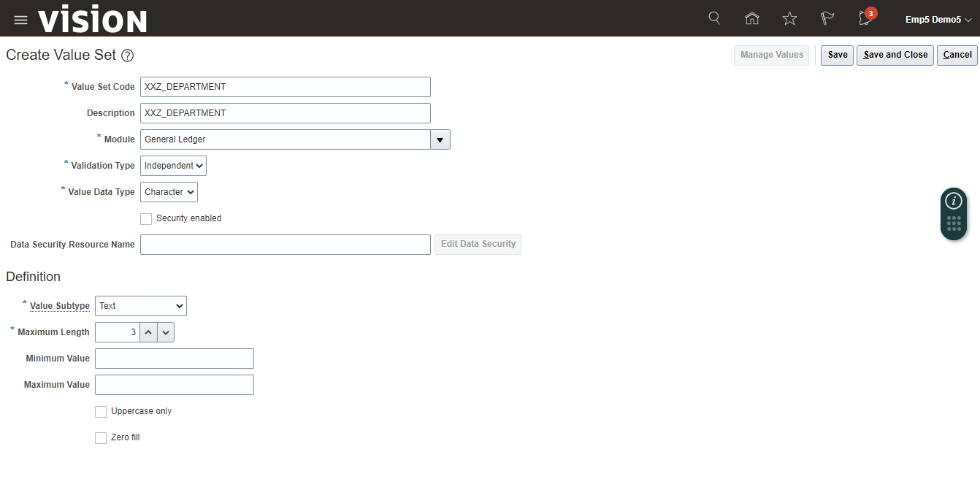

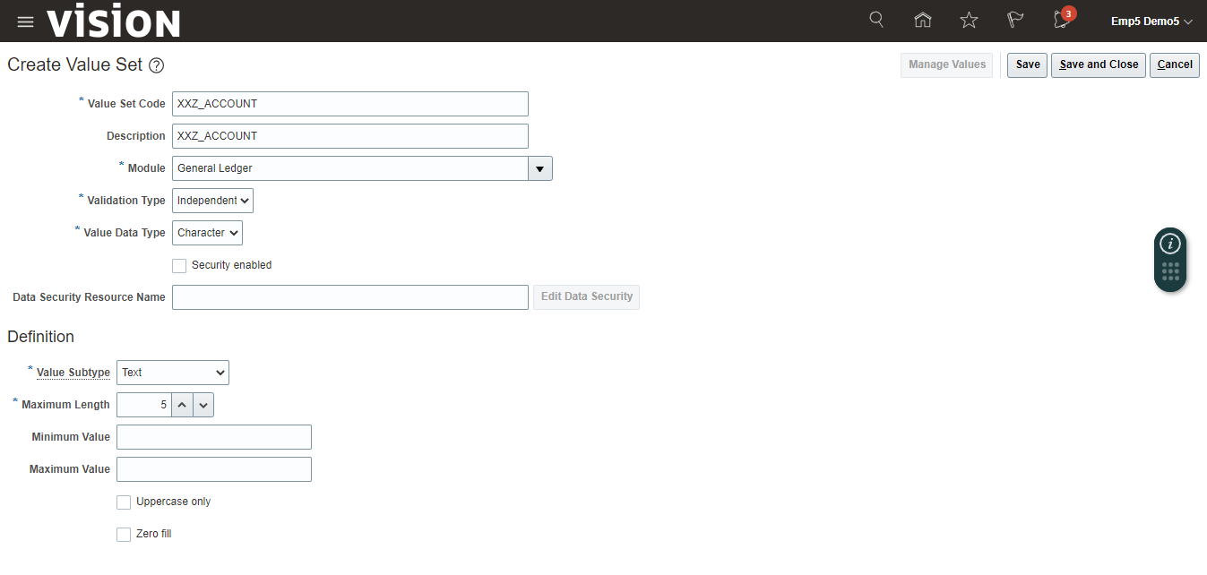

Click on “Save and Close” after creation of all the value sets.

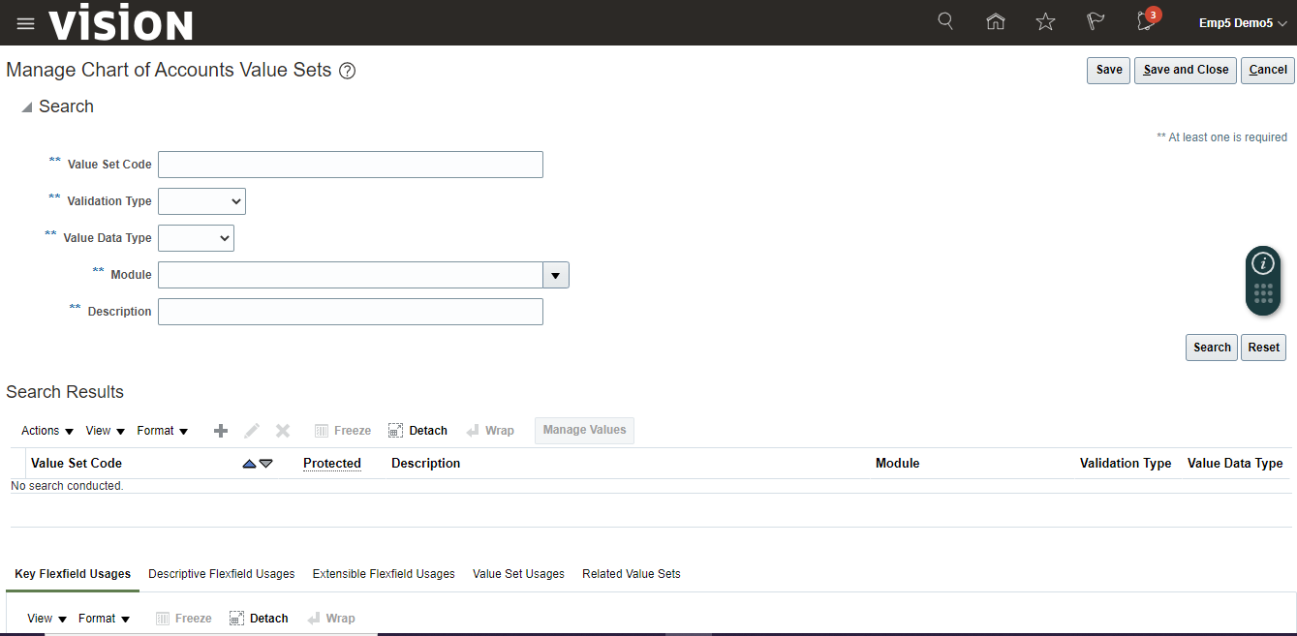

2. Create Char of Accounts Structure

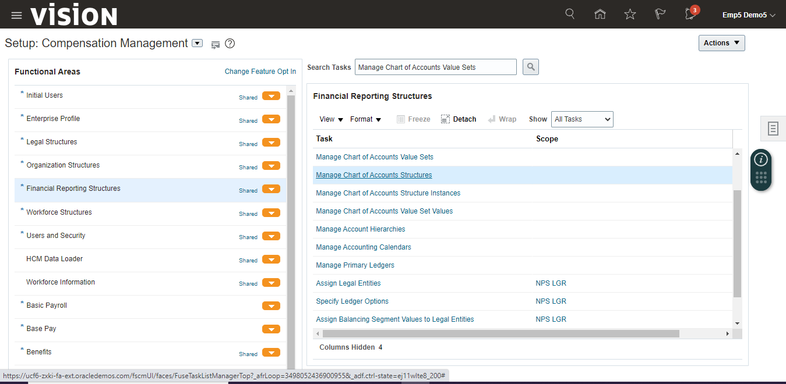

Enter “General Ledger” in Module and click on the “Search” Button.  
Select “General Ledger” from search result and click on “Manage Structures”.

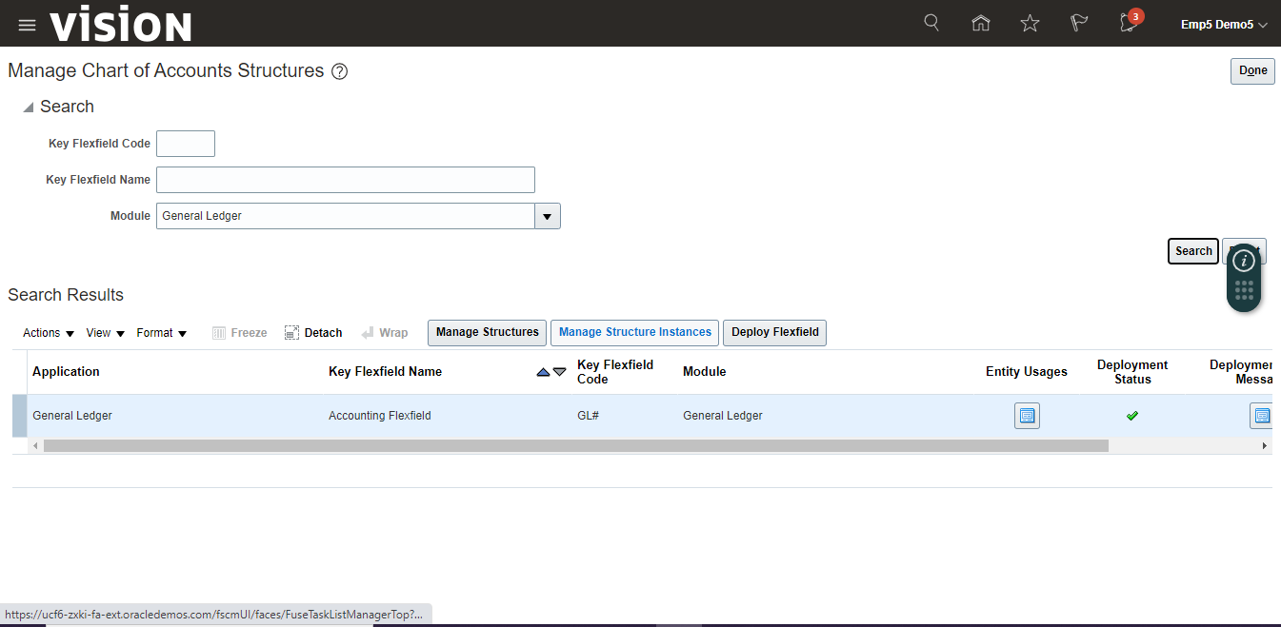

Click on create (+) icon to create a new structure.

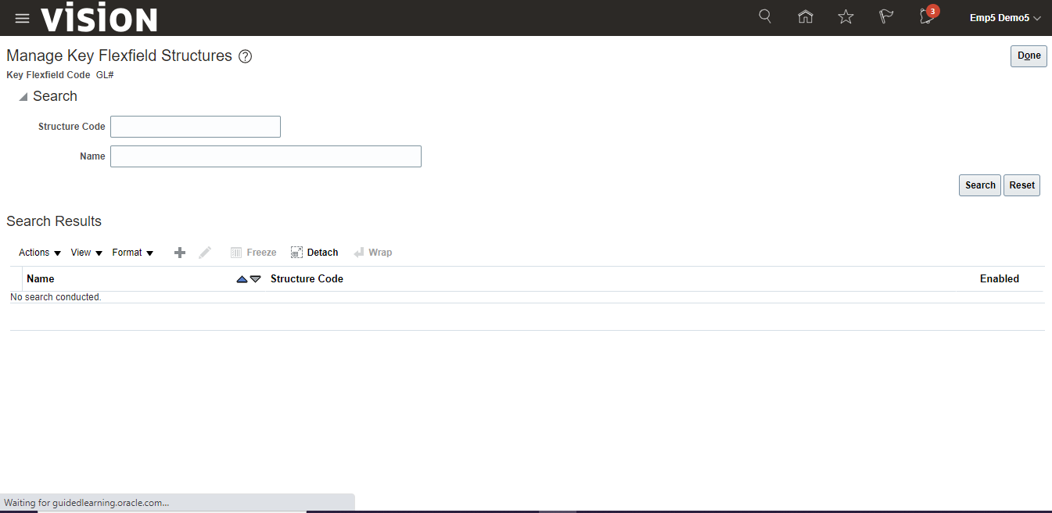

Enter Structure Code, Name, Description and select Delimiter and Click on “Save” button.

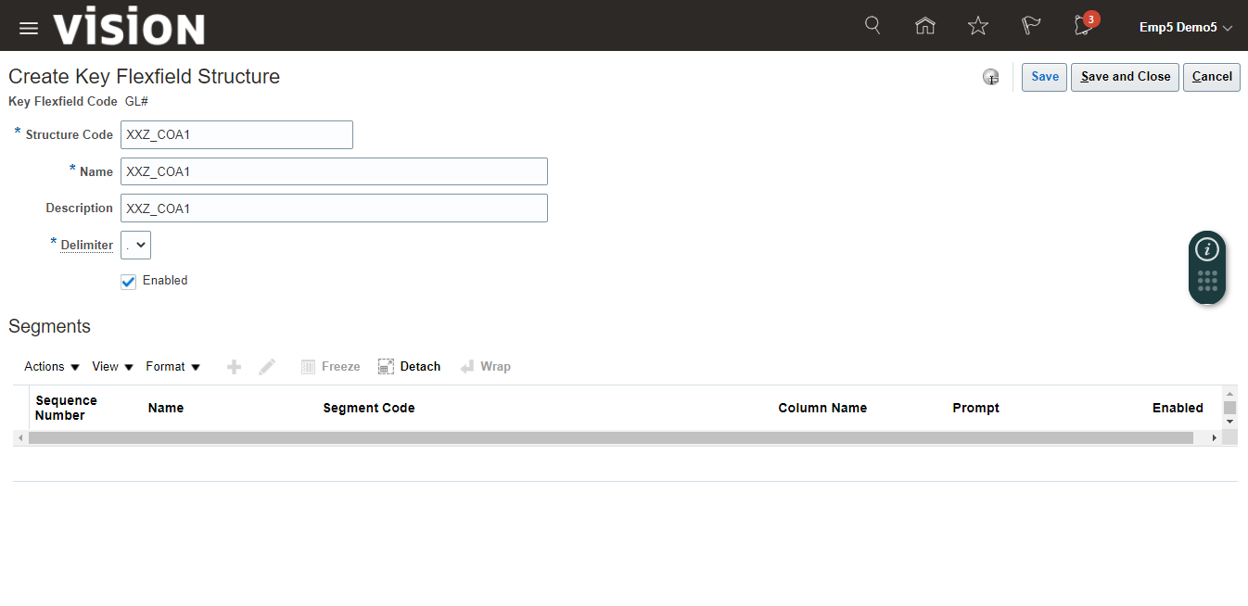

Click on Create (+) icon to add segments

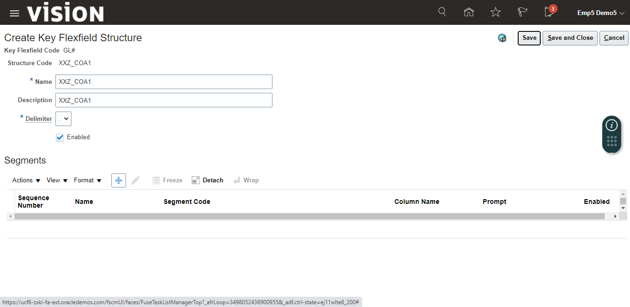

Enter details and click on “Save and Close”.

(Note – Segment Label is mandatory for deployment)

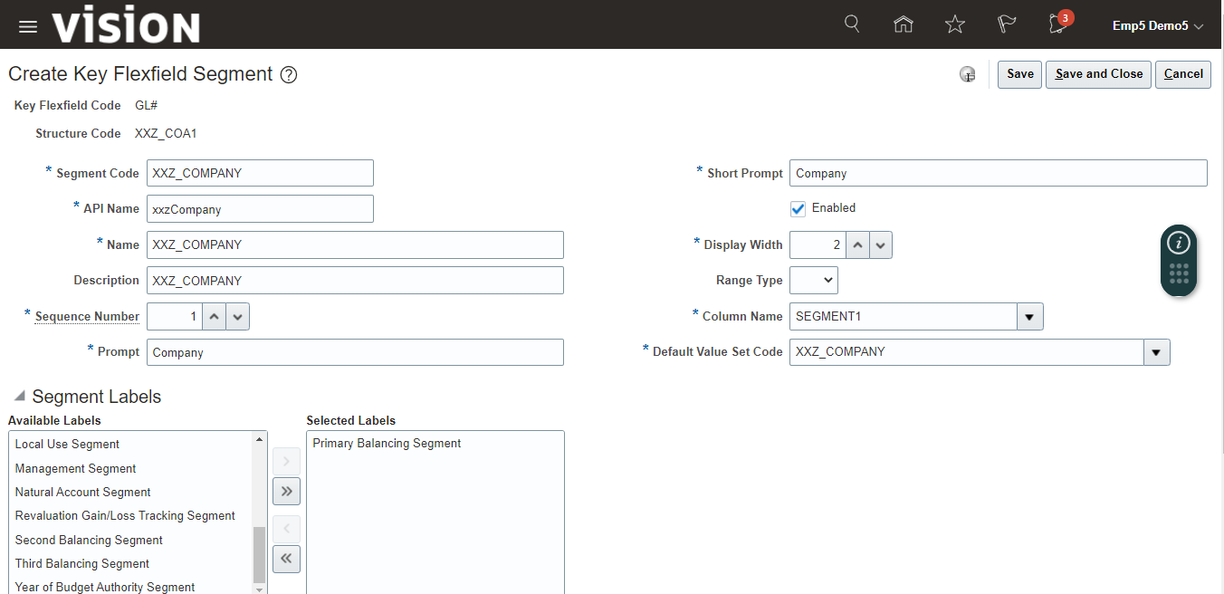

Click on create (+) icon to add another segment

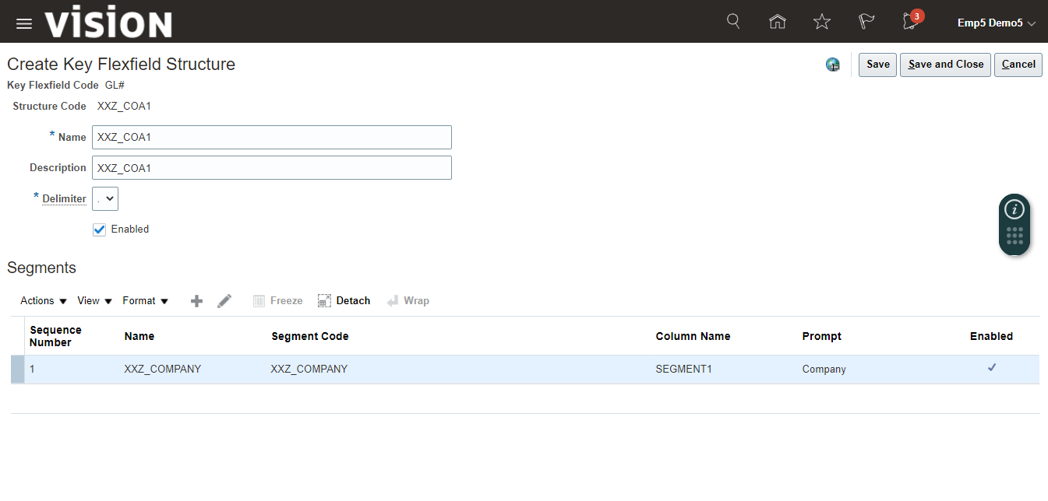

Enter details and click on “Save and Close”.

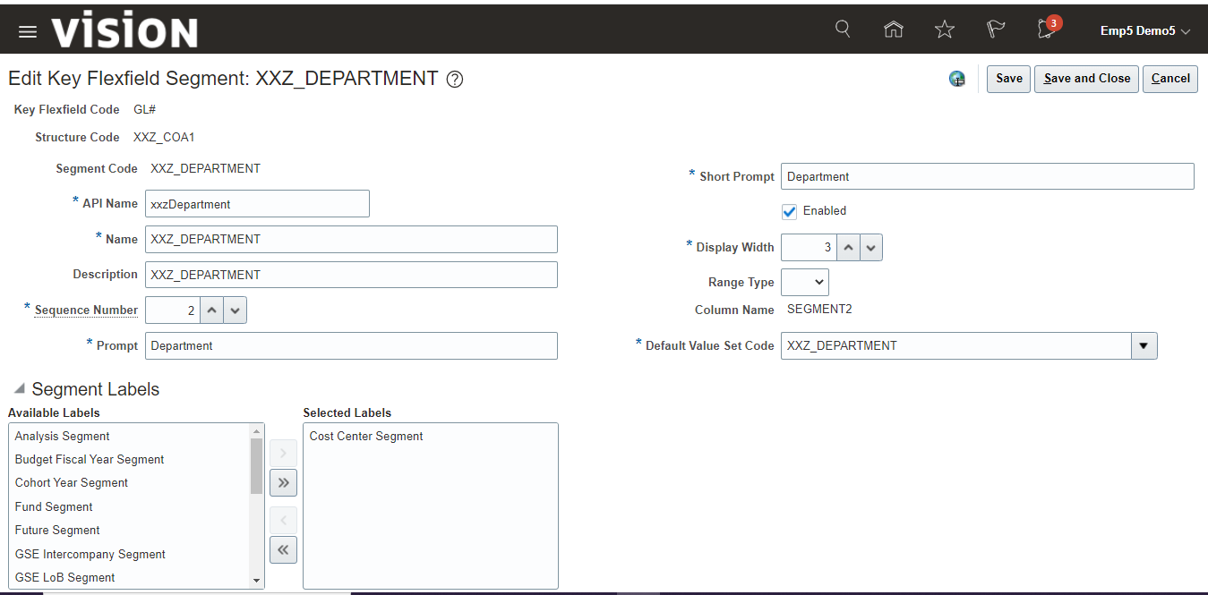

Click on create (+) icon to add another segment

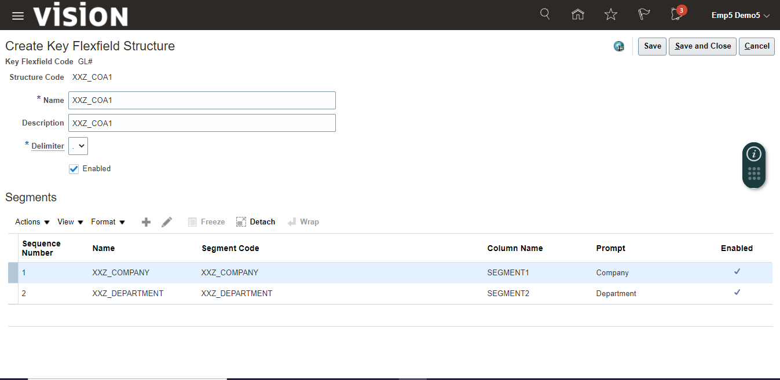

Enter details and click on “Save and Close”.

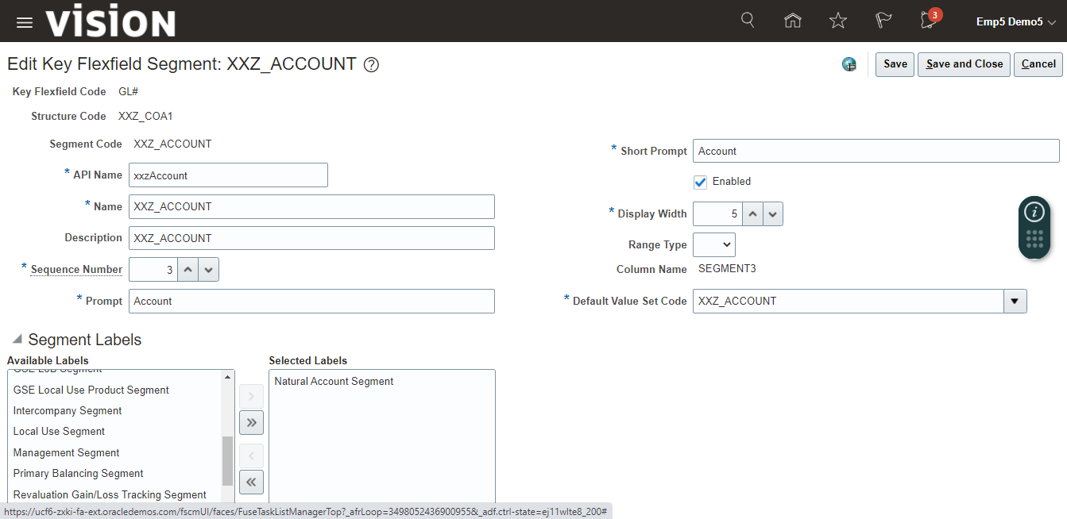

Once all the segments added, click on “Save and Close”.

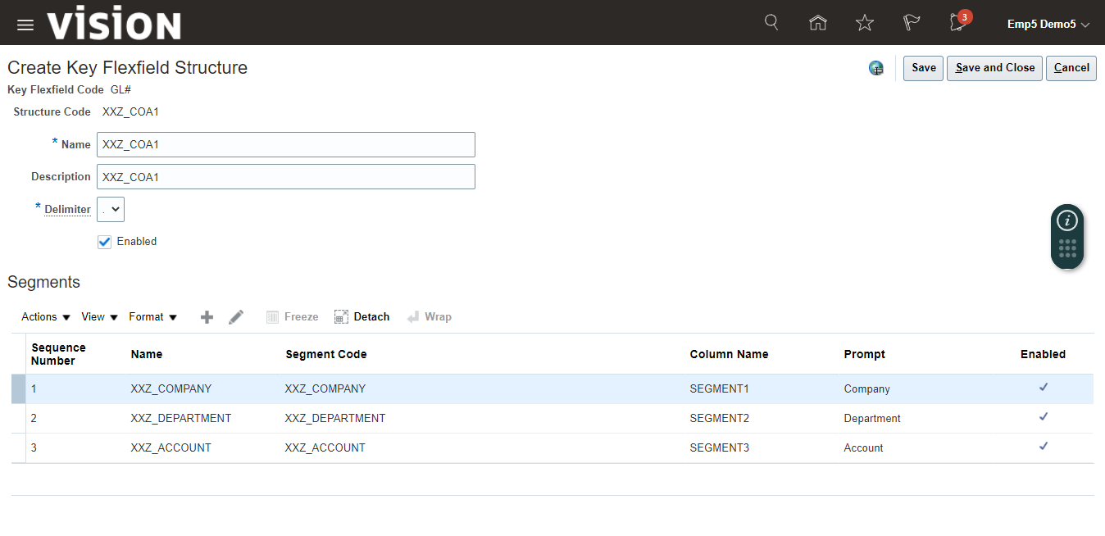

Search and see your created Structure.

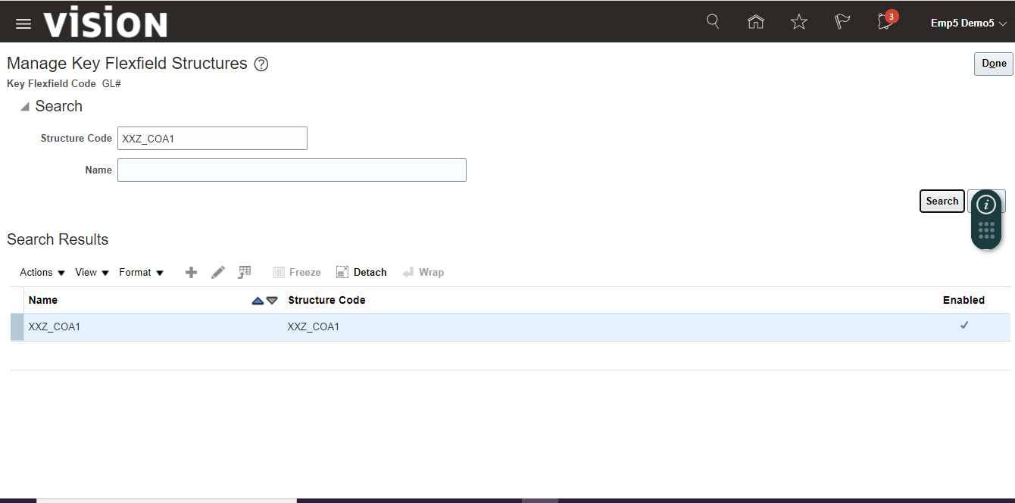

3. Create COA Instance

It is a new functionality provided by Oracle in Fusion in compare to EBS R12.  
 It is a variation of COA Structure that can be used for different ledgers.

Click on “Manage Structure Instances”.

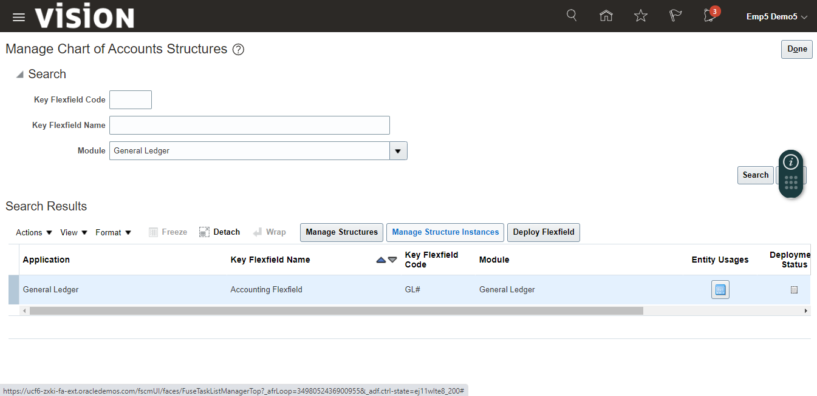

Click on create (+) icon to create Structure Instances

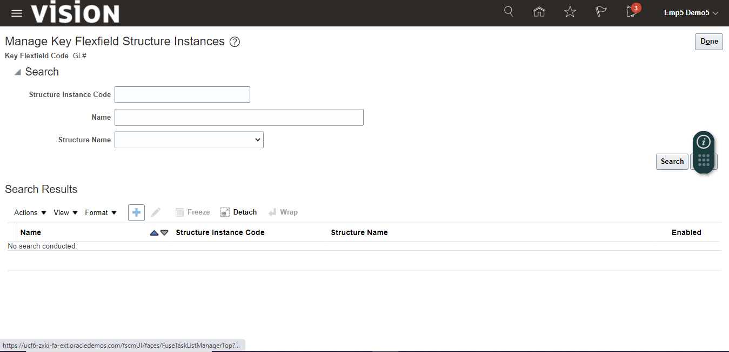

Enter the details, select segment, and click on edit icon.

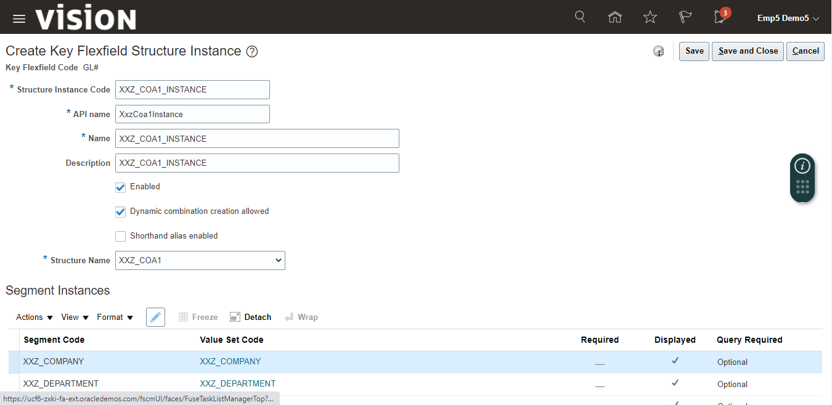

Make it Required by Select check box.

You can do some other changes also like make default type as Constant or by SQL query etc. and click on “Ok” button.

And repeat the same for all the segments.

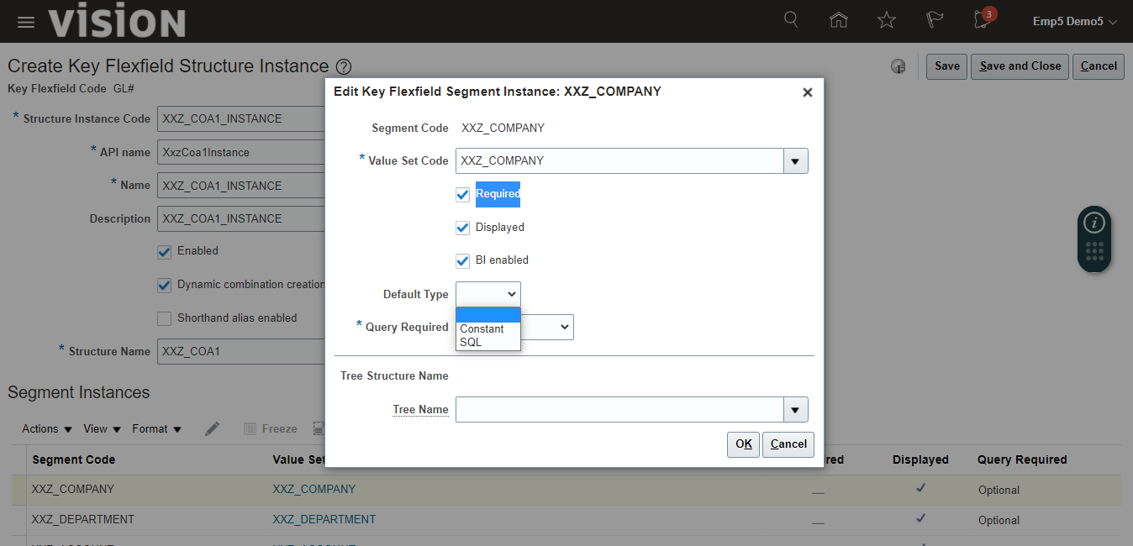

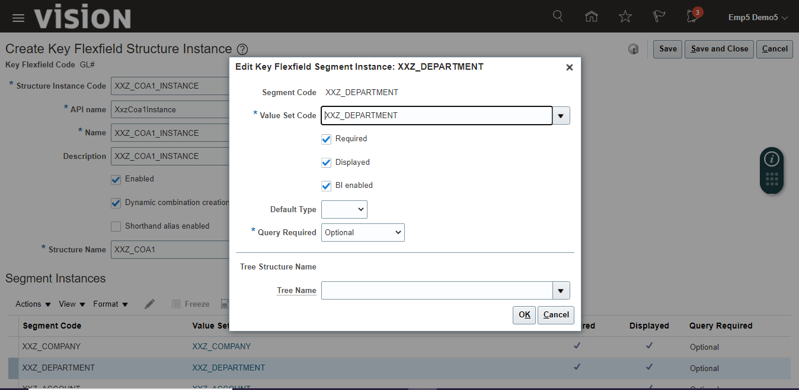

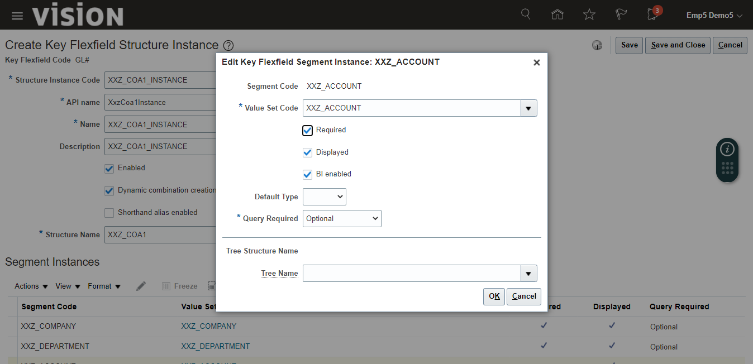

Click on “Save and Close”.

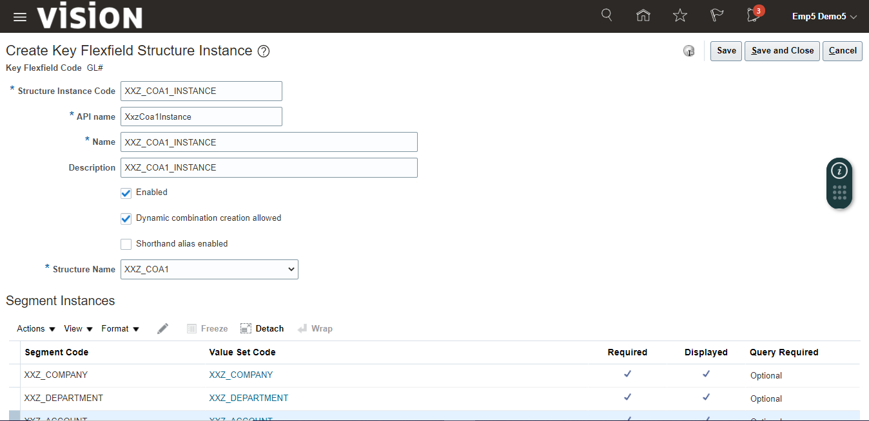

Search your Instance and you can see its created.

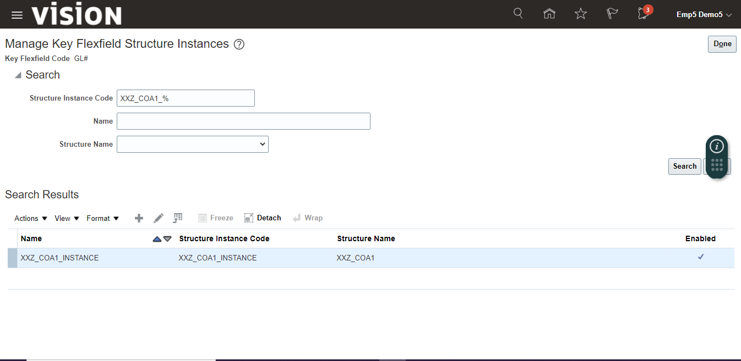

4. Deploy Chart of Account.

Click on “Deploy Flexfield” button.

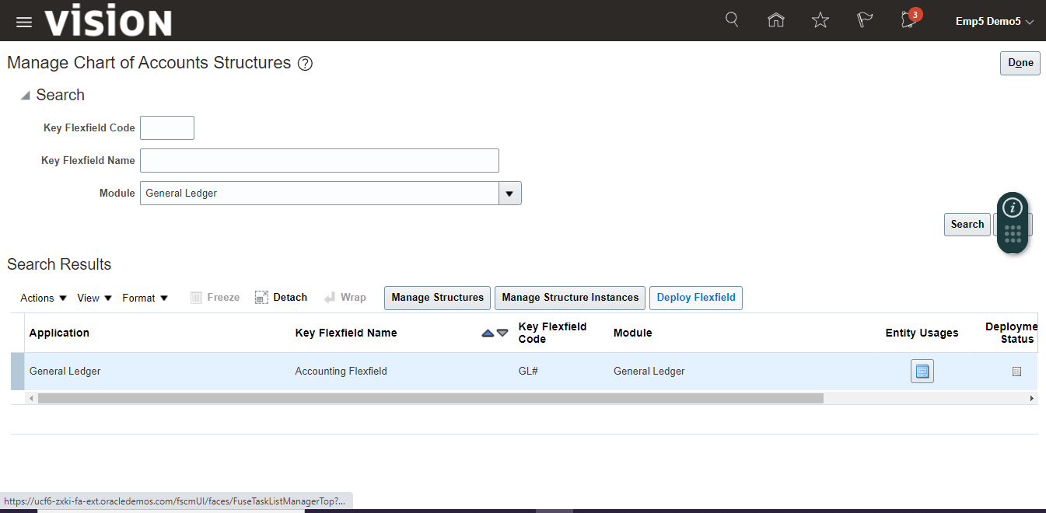

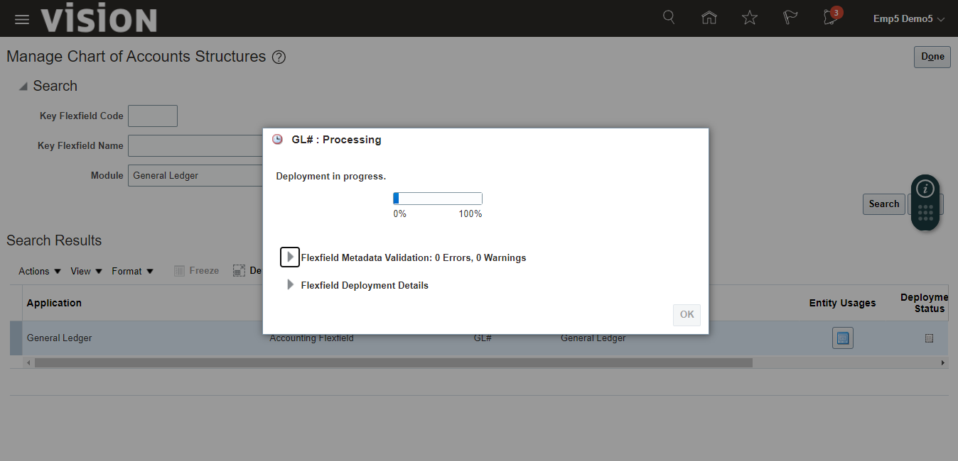

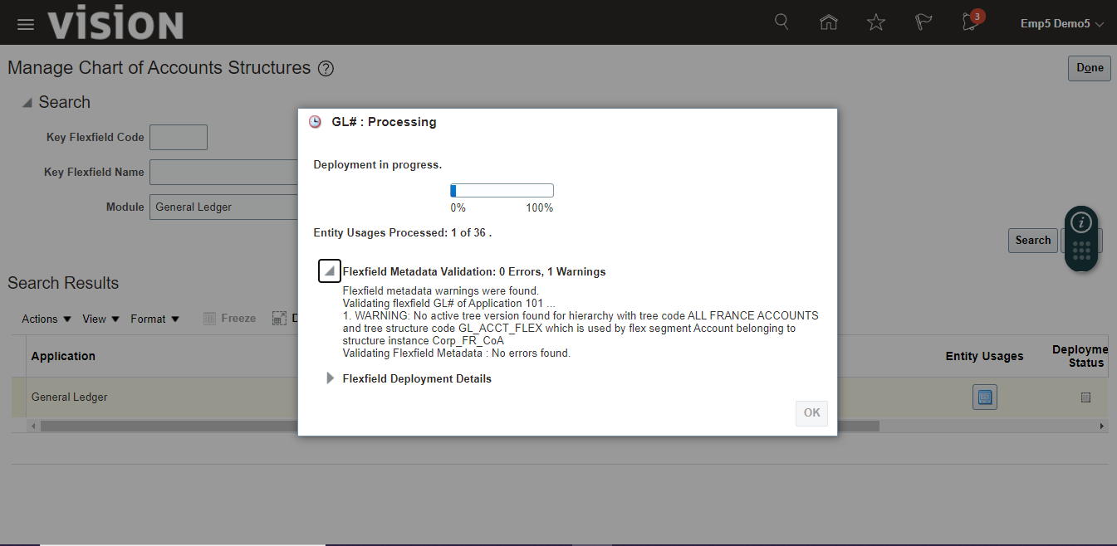

Click on “Ok” once deployment is completed.

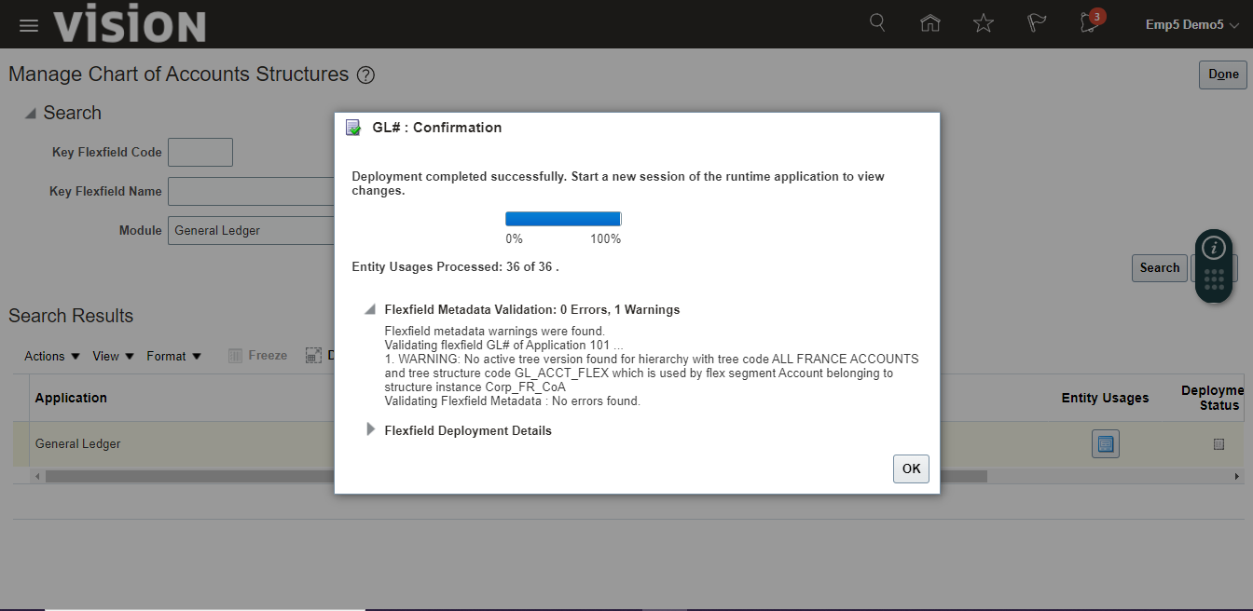

You can see deployment status

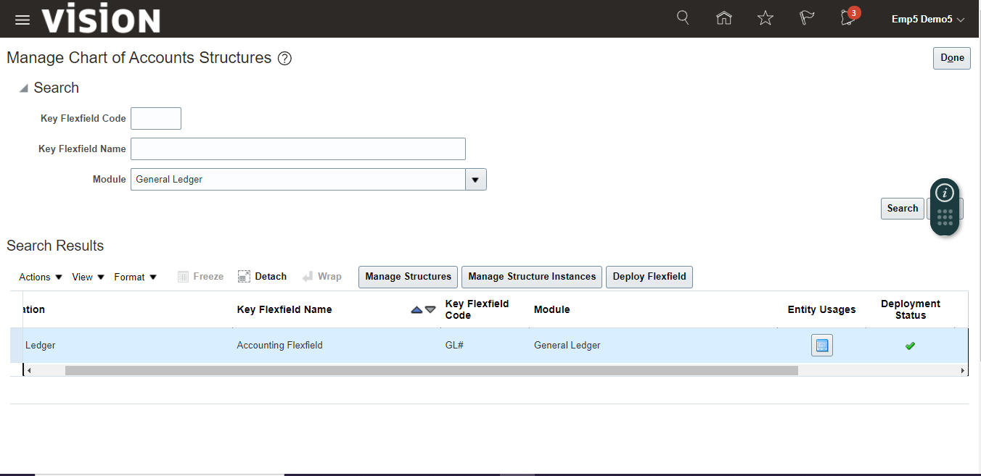

6. Enter values for segments

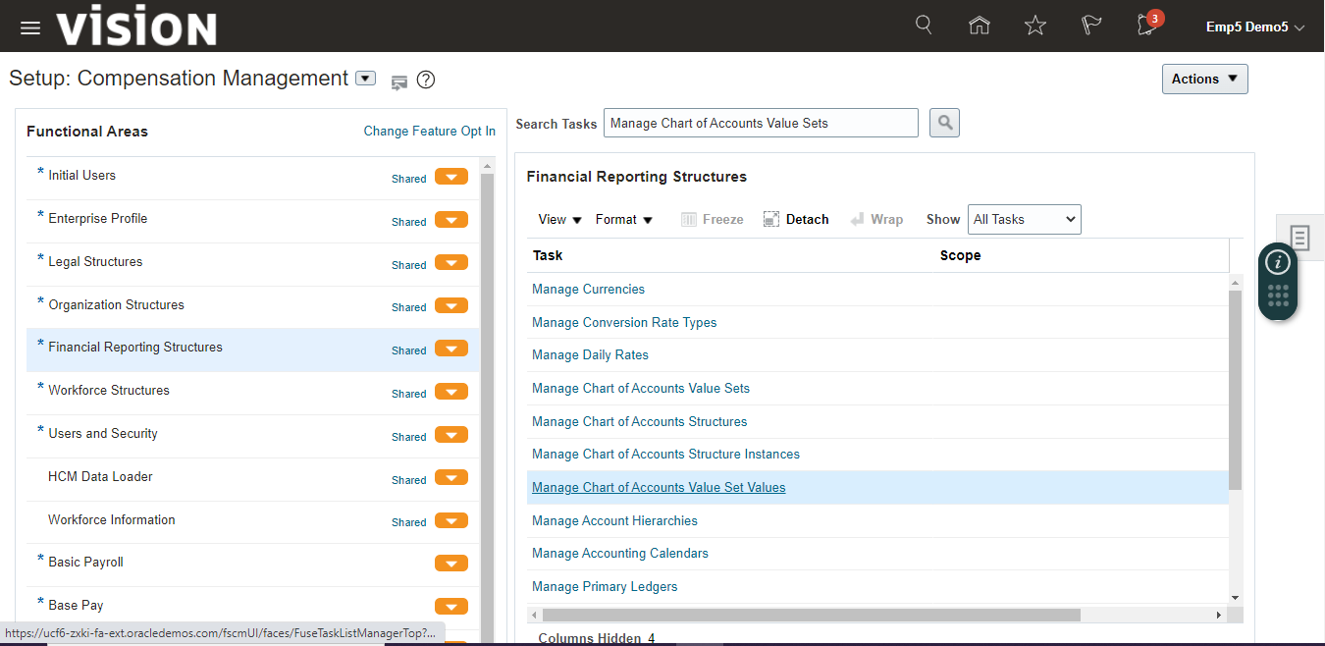

Search Value Set and select value set from the search result and click on “Manage Values” button to add values.

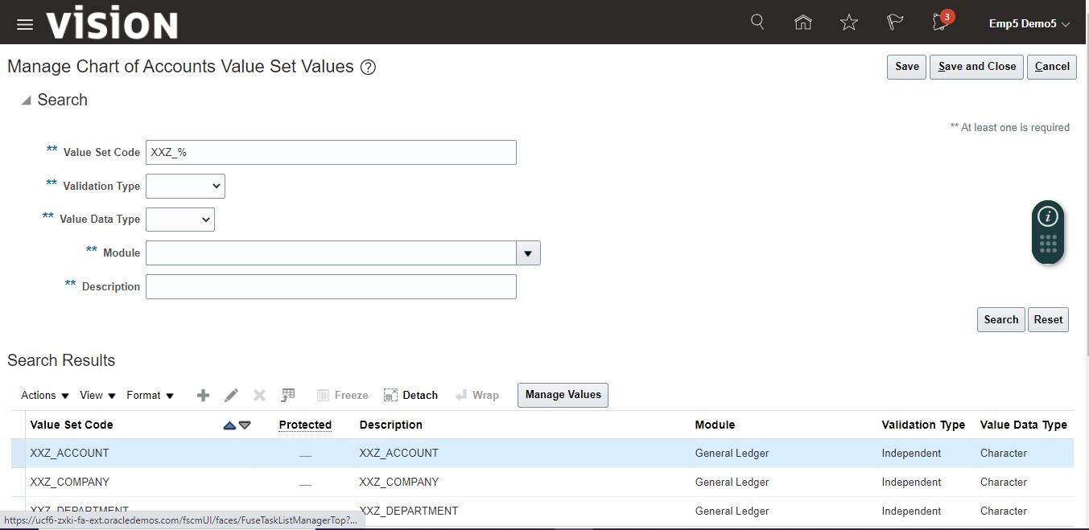

Click on create (+) icon

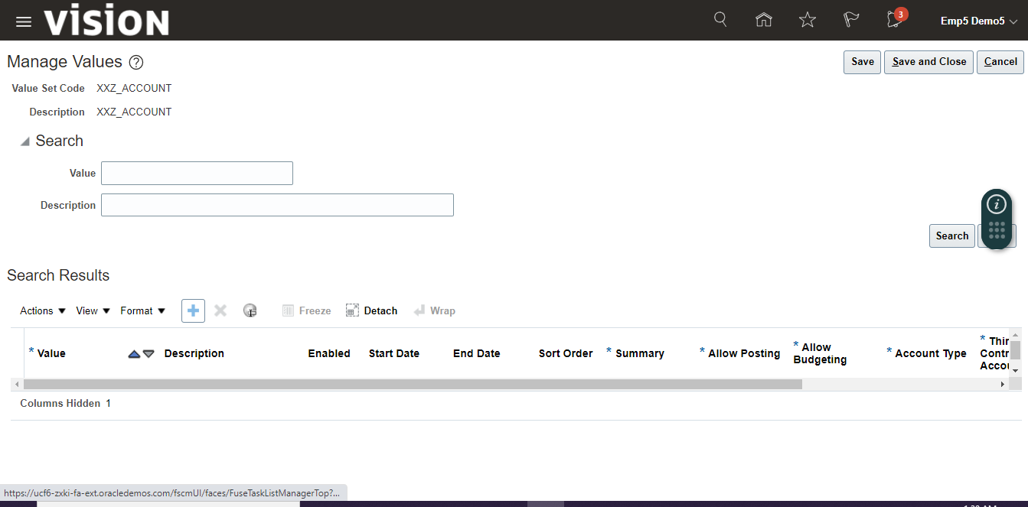

Enter values and click on “Save”.

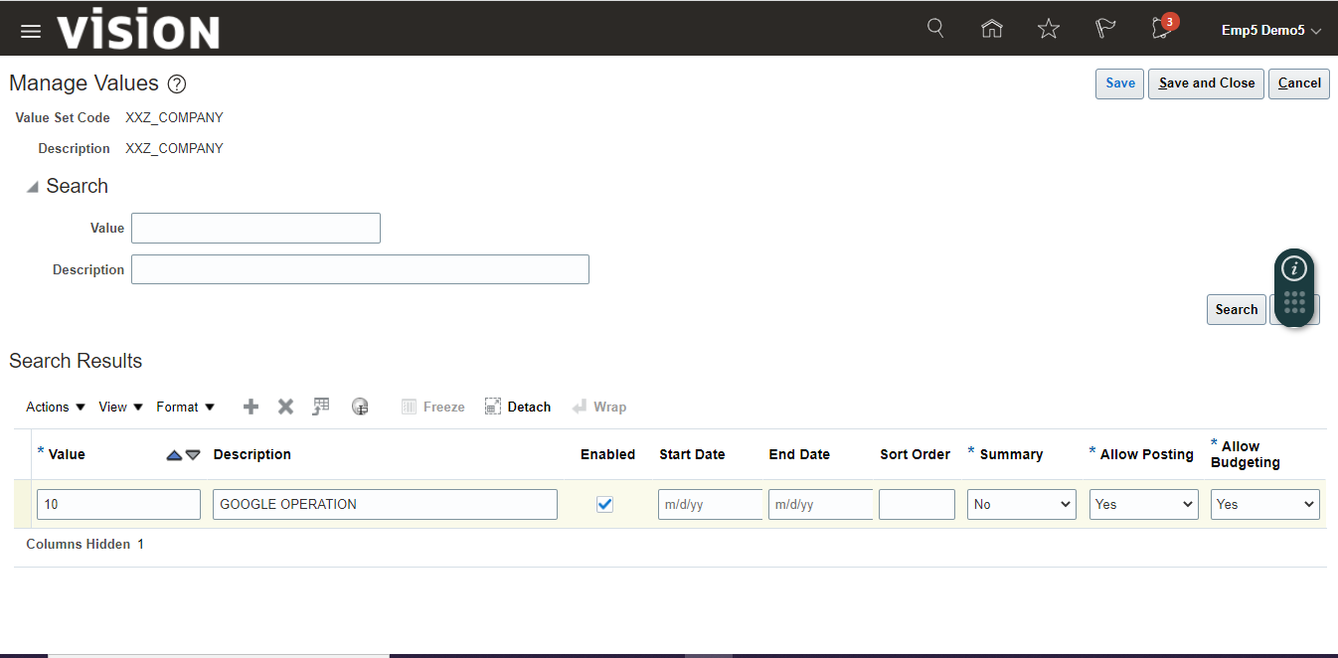

Enter all the values and in last click on “Save and Close”.

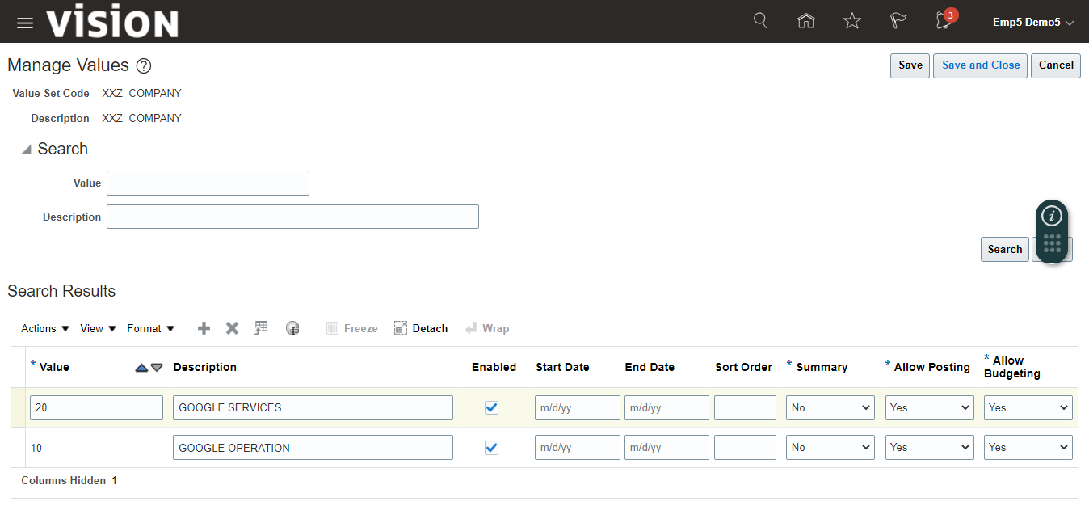

Enter same for other value sets

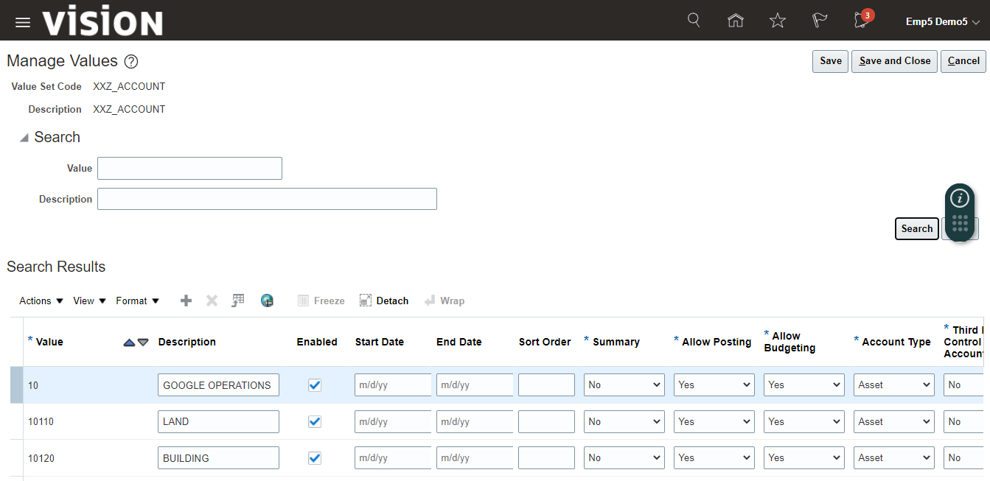

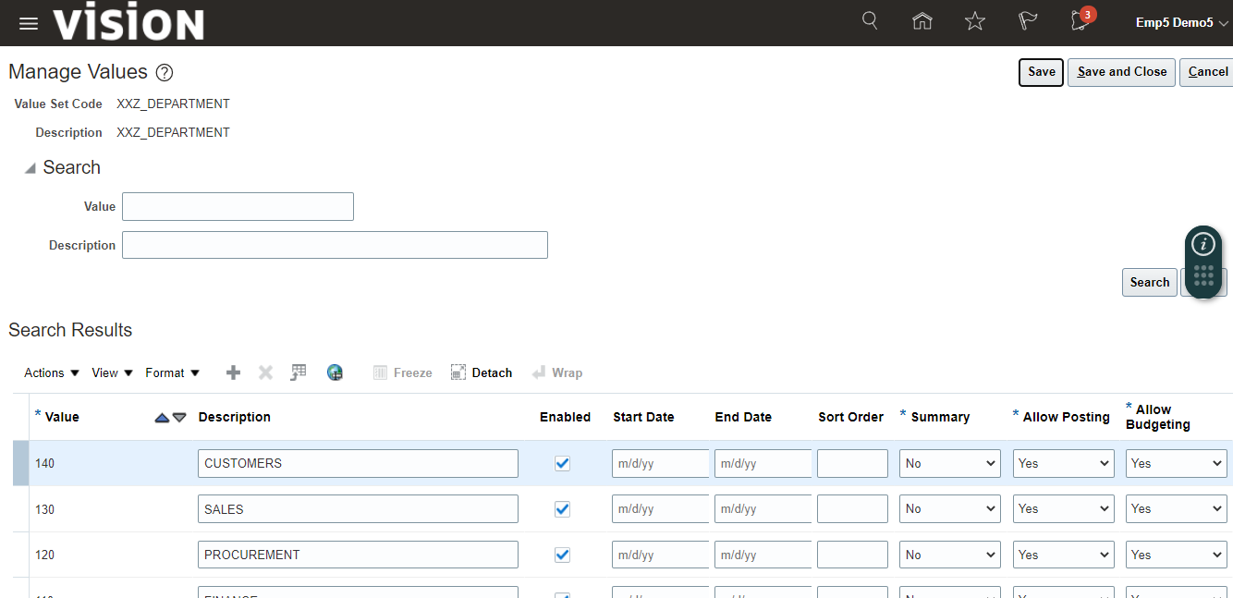

Finally click on “Save and Close”

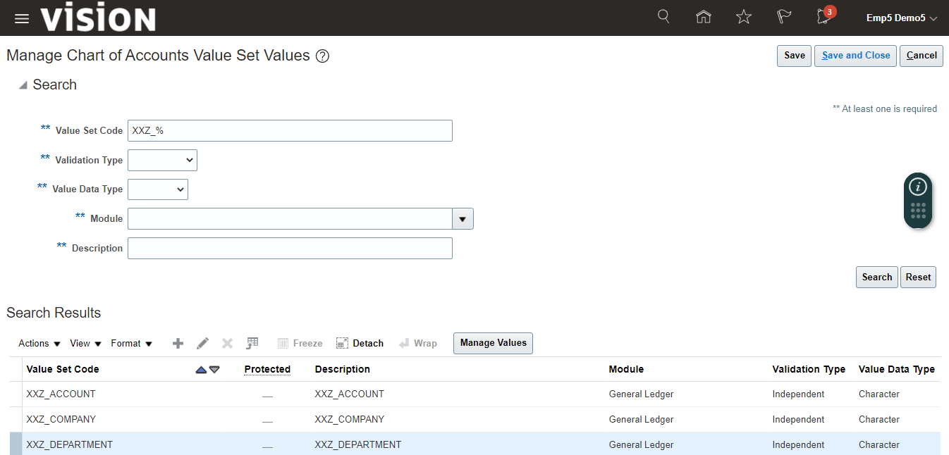

CVR (Cross-Validation Rules)

It is used to define a Condition filer or Validation filter

DFF (Descriptive Flexfields)

It enables us to capture additional information for users which is not available on standard page provided by oracle.

We use DFF to show additional column on form.

We have two types of DFF.

1. Global Context  
   This DFF will be visible for every user who is going to open the specific page.
2. Context Sensitive  
   In this DFF, we can set visibility based on certain condition, so that only user with the certain condition can see the DFF.

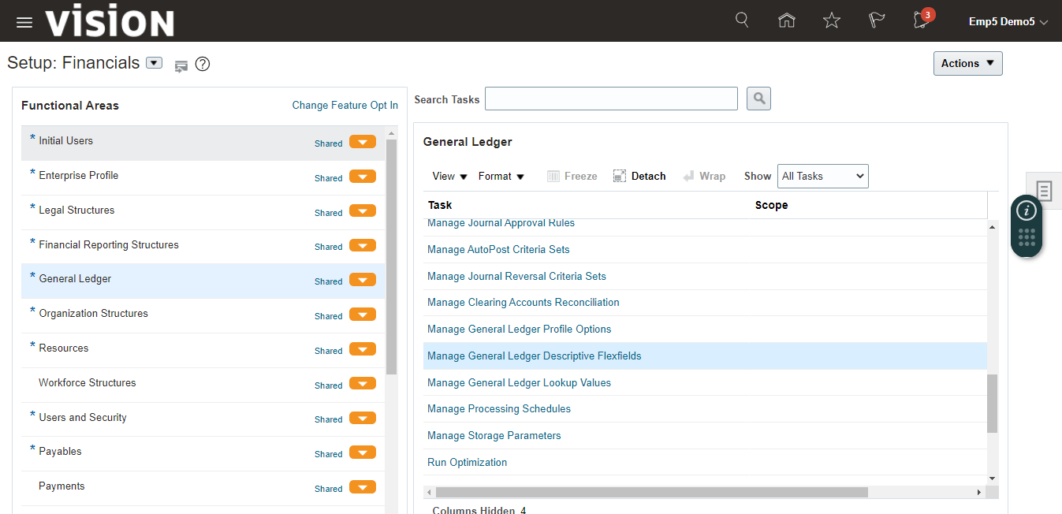

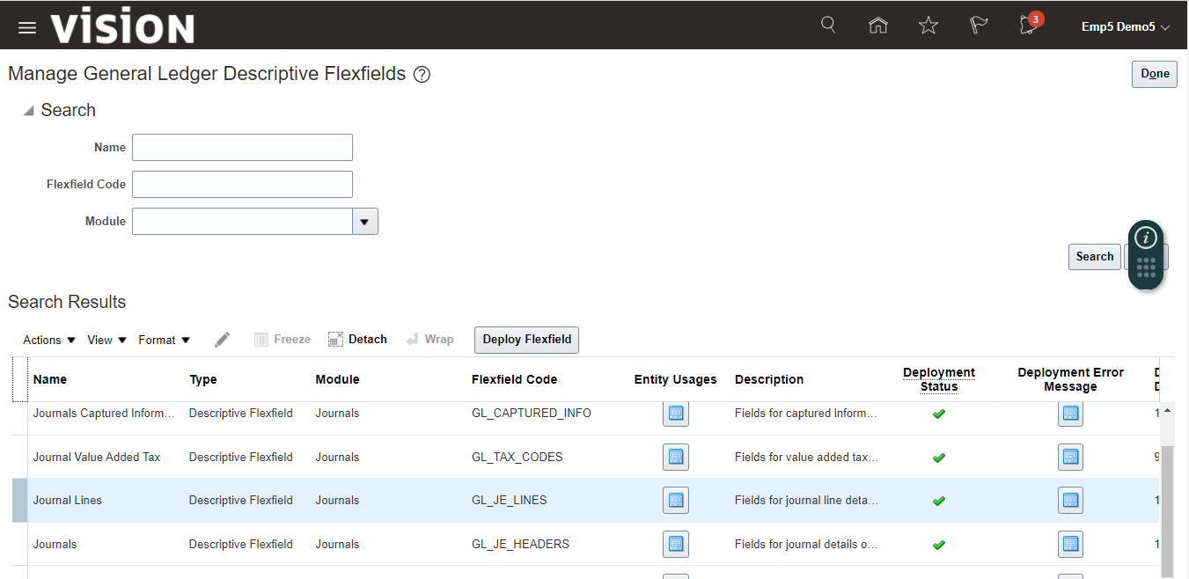

Click on + icon

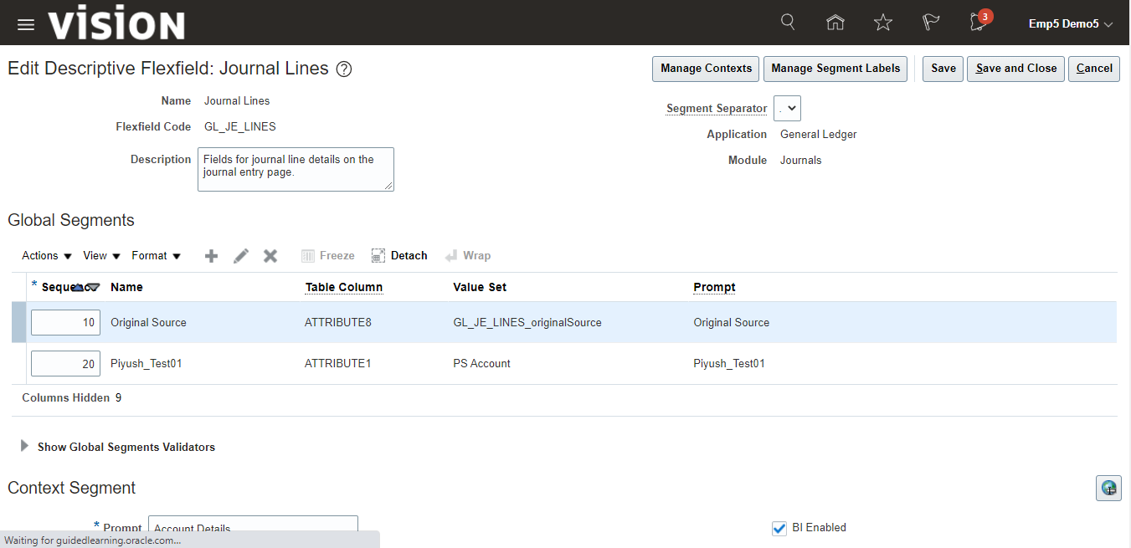

Enter Details and Click on “Save and Close”.

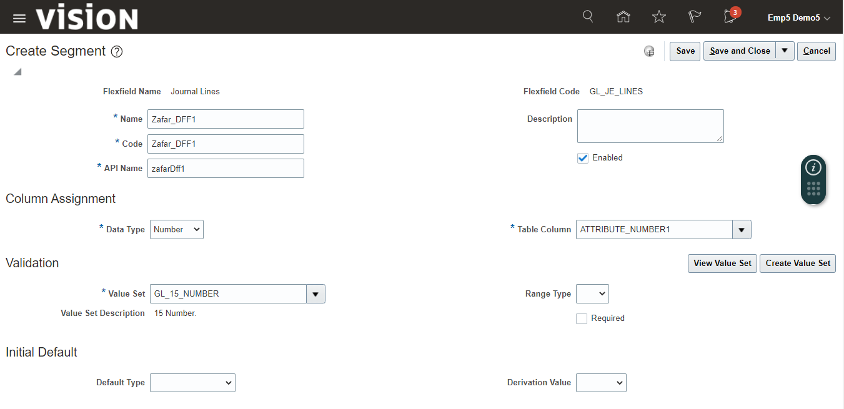

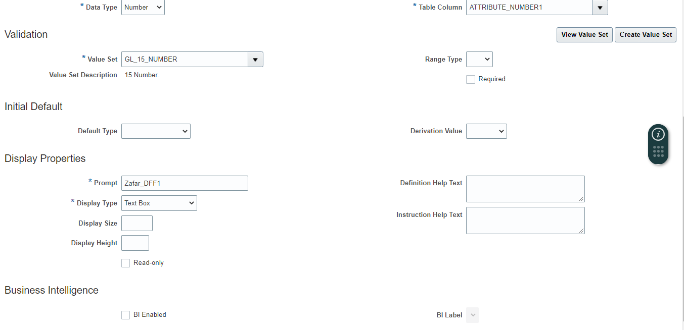

Click on “Save and Close”

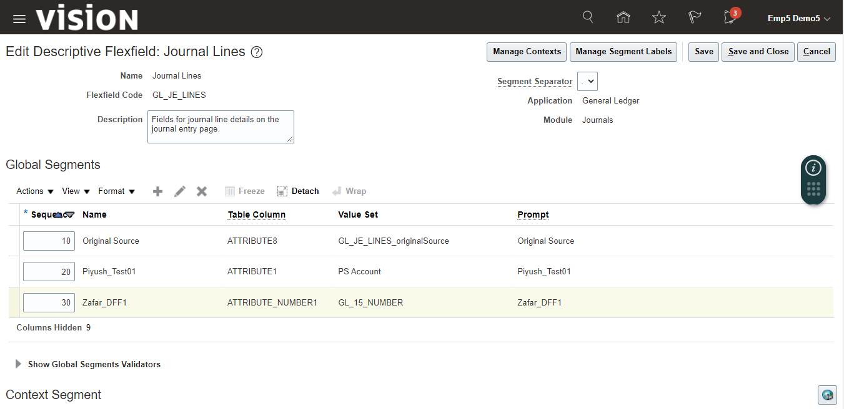

Now, Deploy status is edited, click on “Deploy Flexfield” button to deploy the changes.

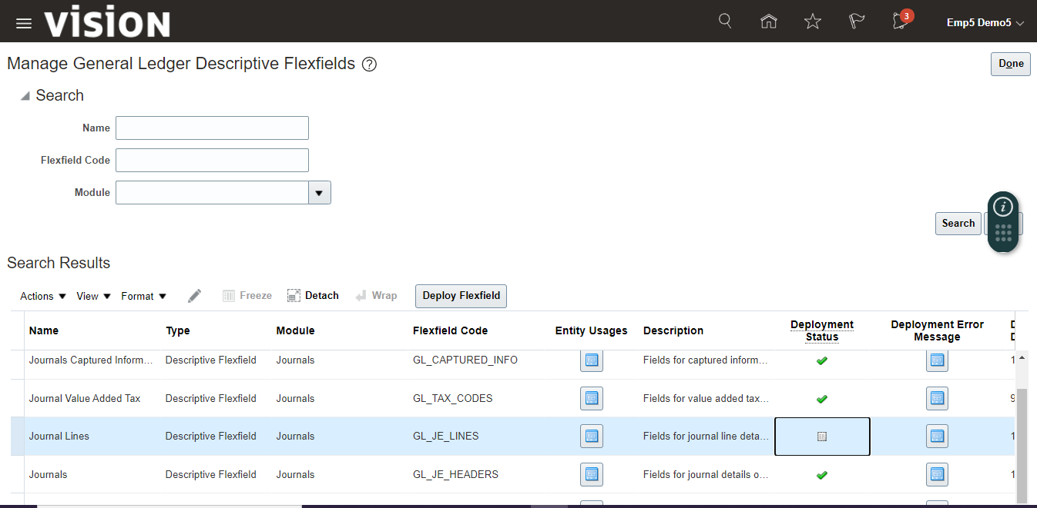

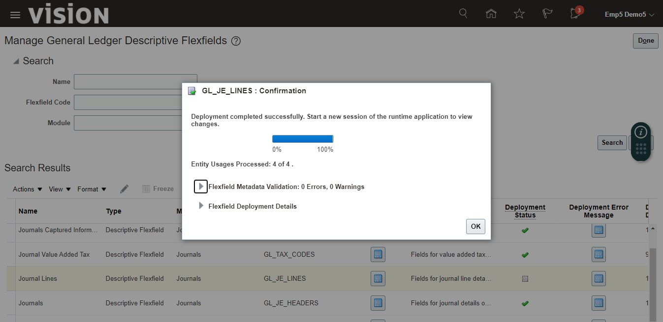

After deploying, you can see the status is changed.

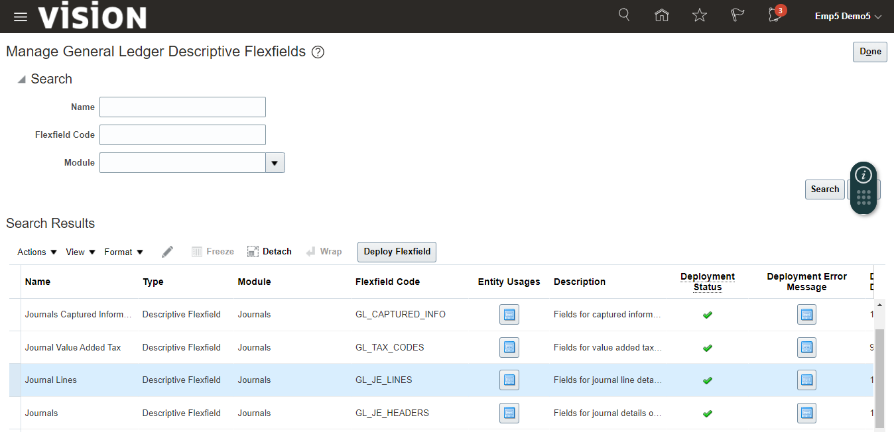

Now navigate to Journals page to see the DFF.

Click on Journals under General Accounting.

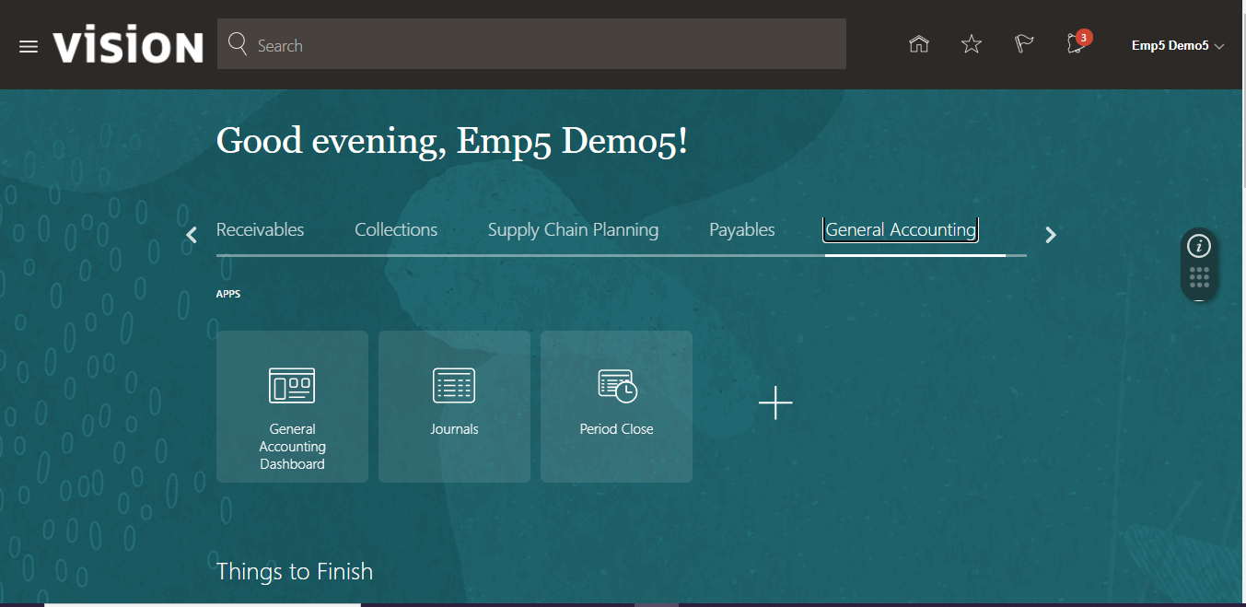

Click on task icon and select “Manage Journals”

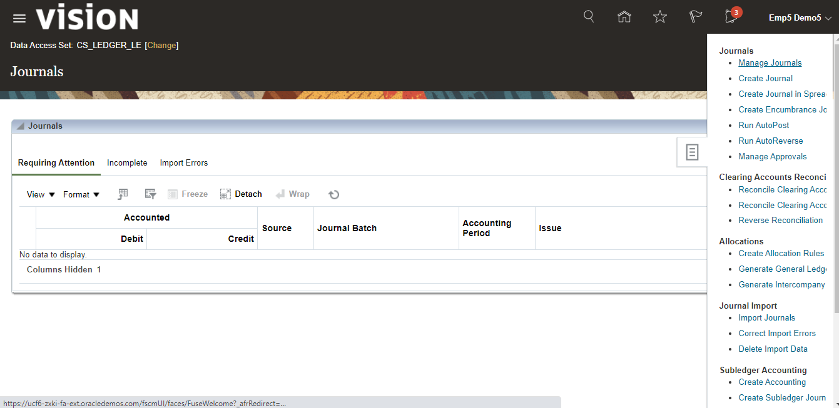

Search any Journal to see the DFF you created.

Click on Journal name to see the details

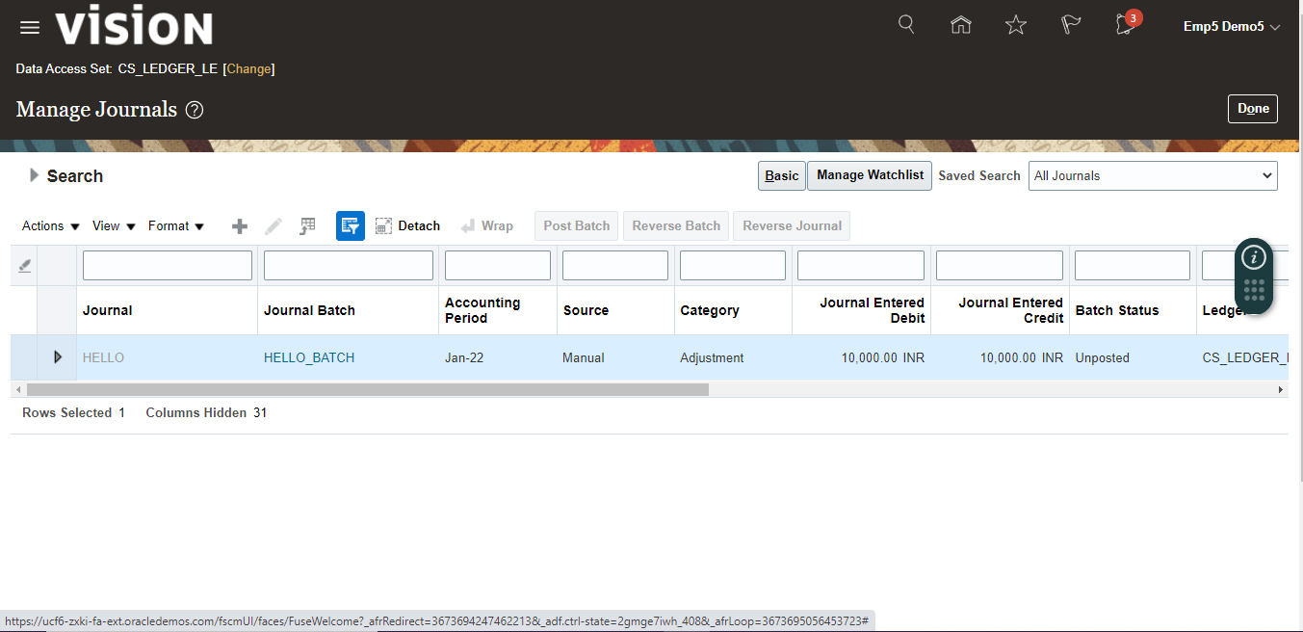

Now, you can see the DFF under Journal lines

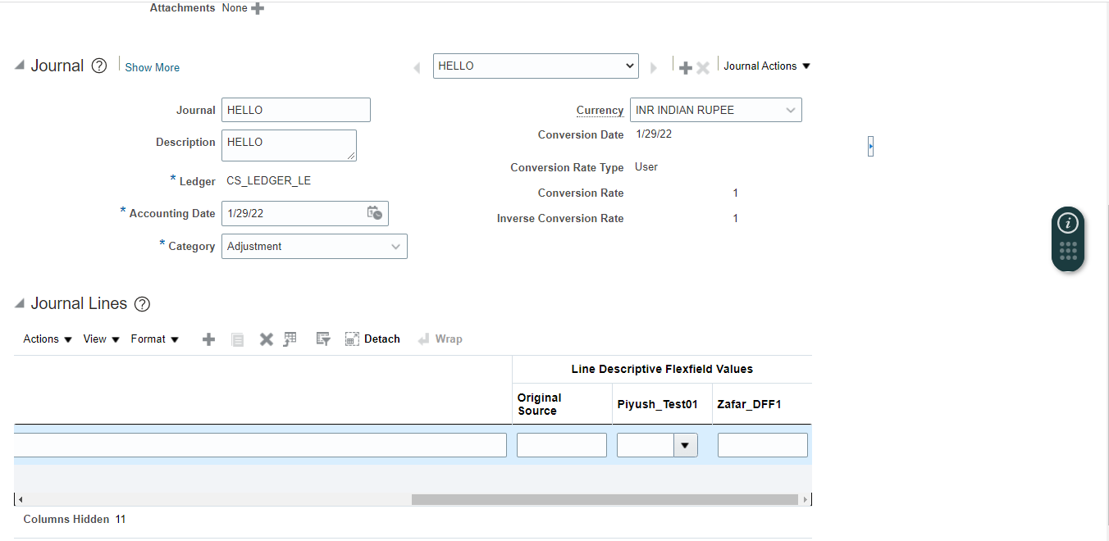

Same you can create DFF for different modules.

Create DFF for Supplier

Go to “Manage Supplier Descriptive Flexfield”

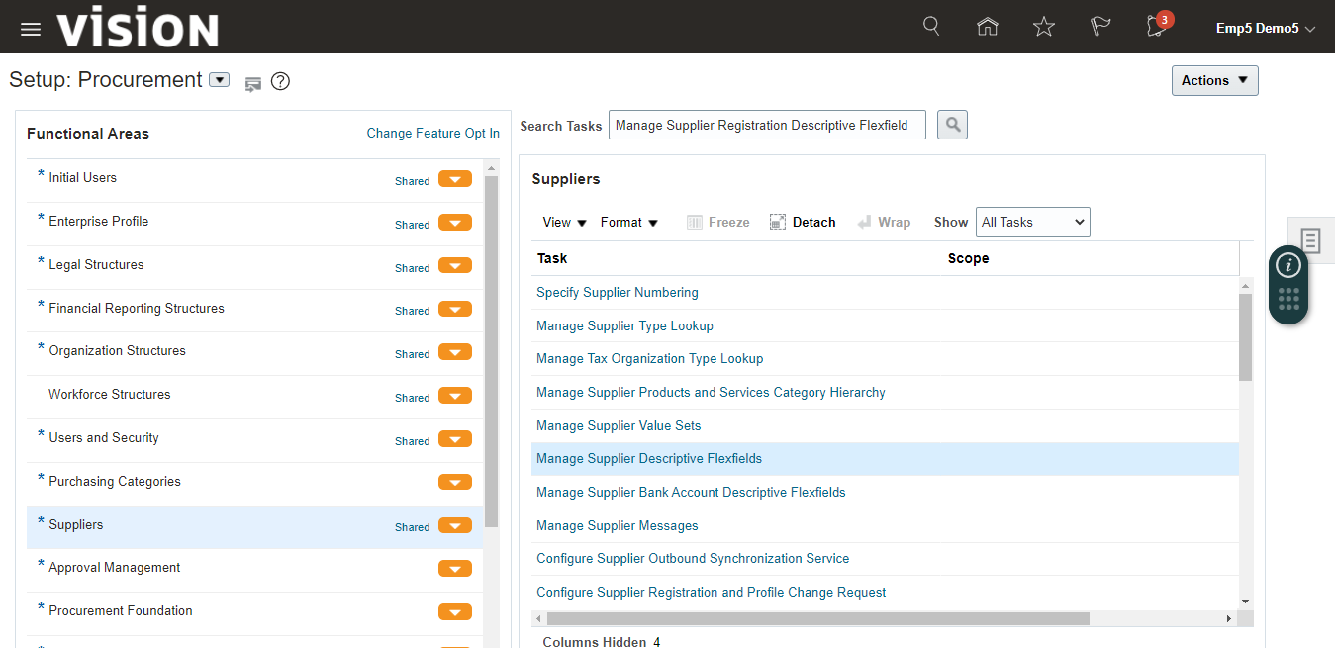

Select “POZ_SUPPLIERS”

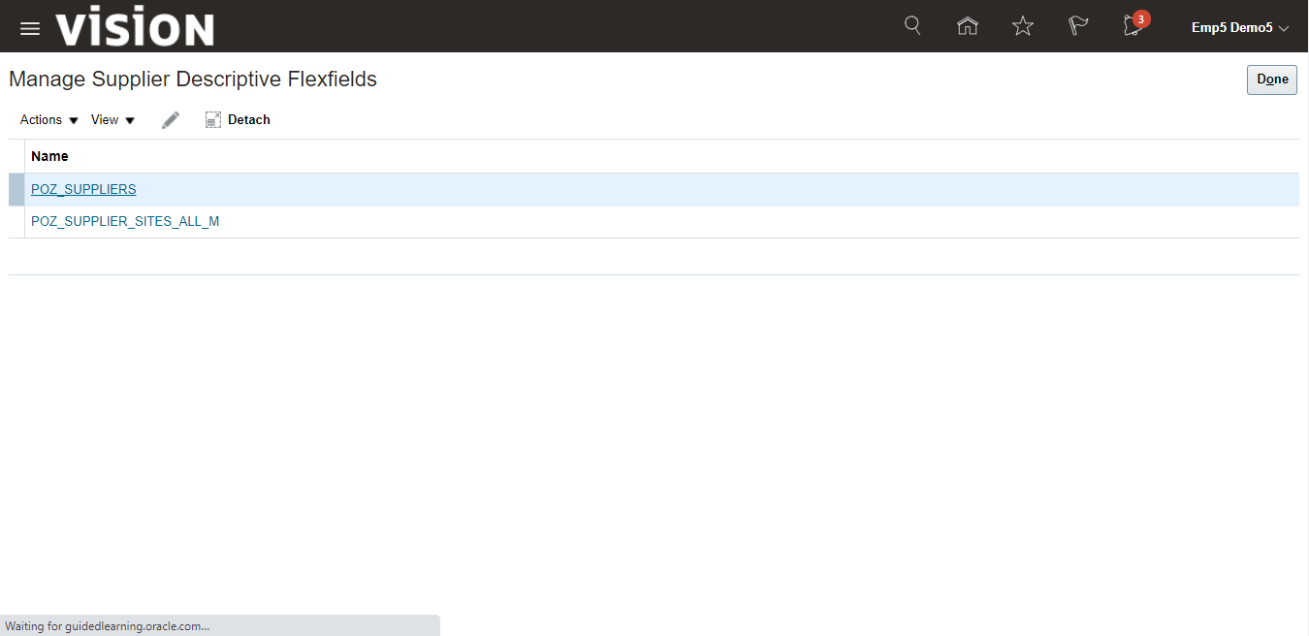

Click on + icon to create new DFF

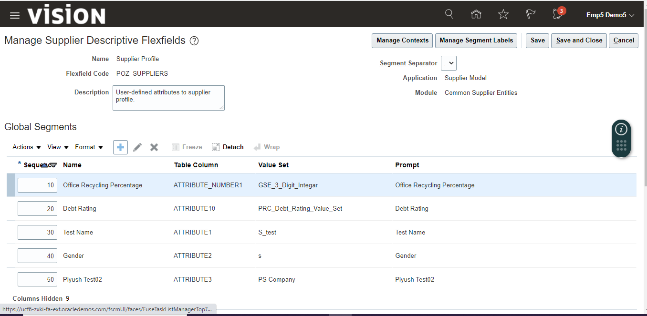

Enter details and Click on “Save and Close”

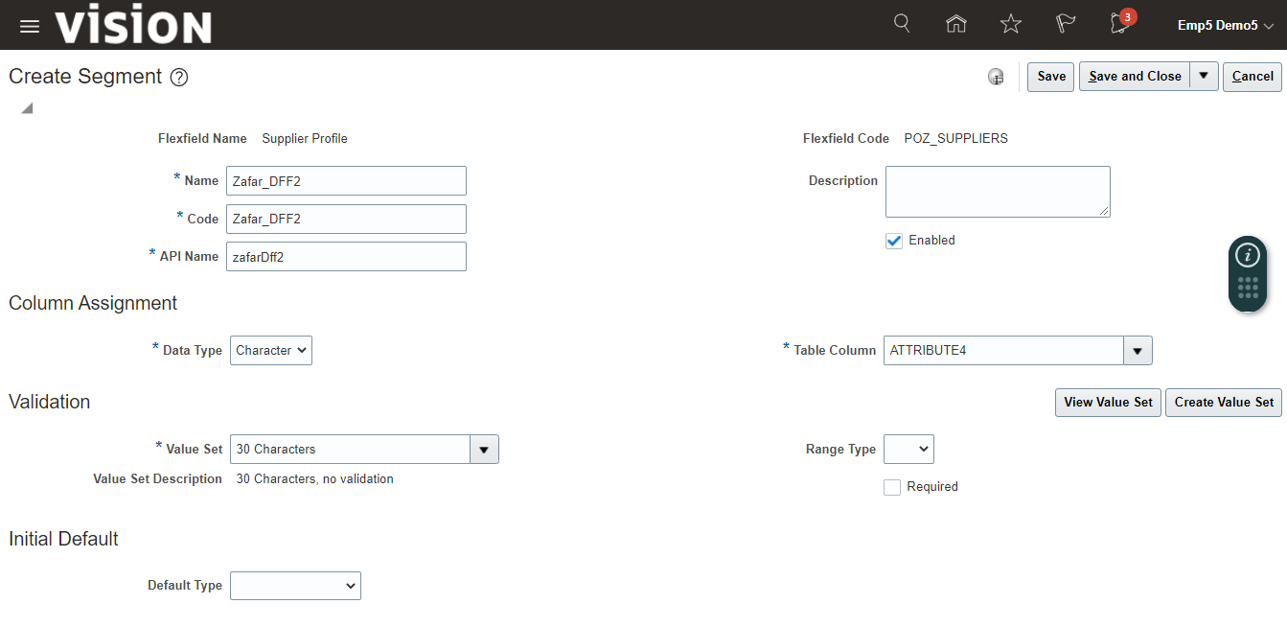

Again click on “Save and Close”

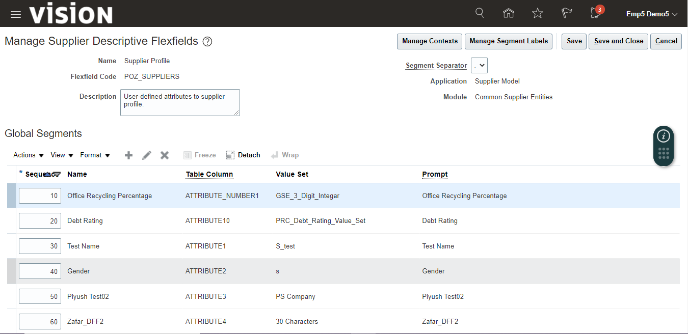

Now you need to deploy the changes, so click on “Deploy Flexfield”

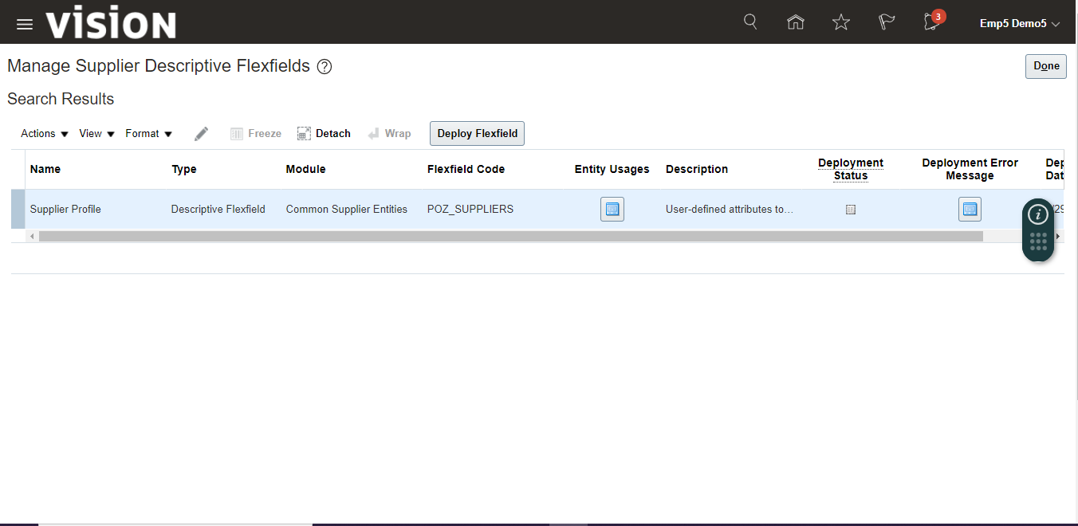

Once deploy completed, click on ok, deploy status will be changed.

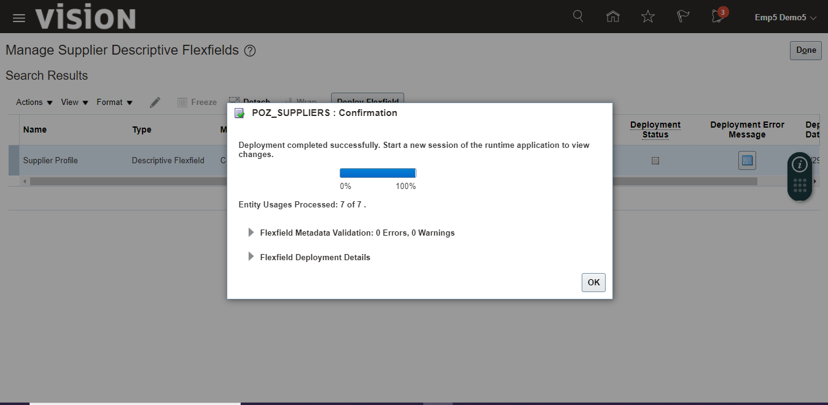

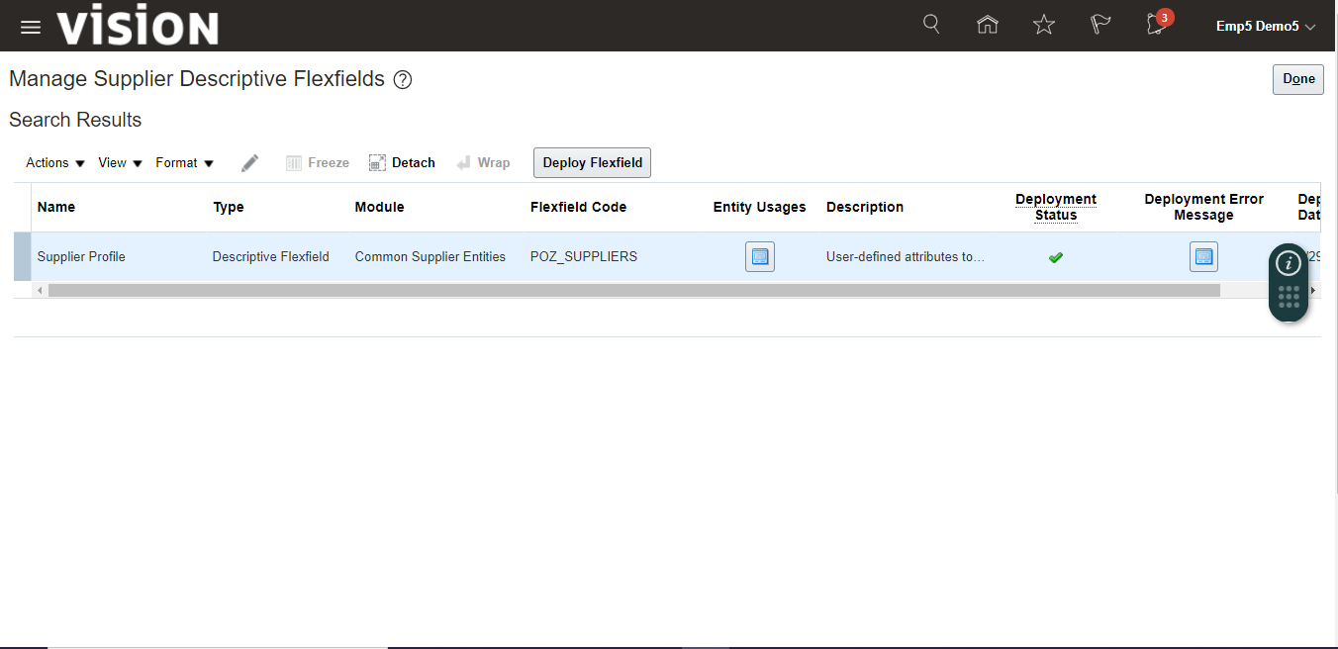

You can see the DFF in Supplier creation form

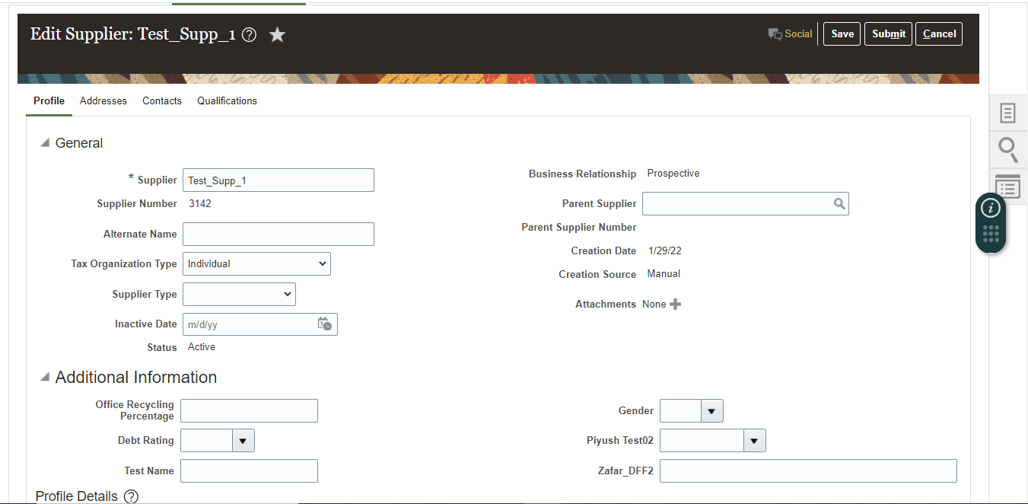

**What is KFF?**

Chart of Account is an example of KFF in oracle application.

KFF is a concept of merging two or more segment in a single column to show.

We can add upto 30 different segment in a single KFF field.

Account Structure like Code Combination, Item Structure are example of KFF.